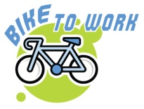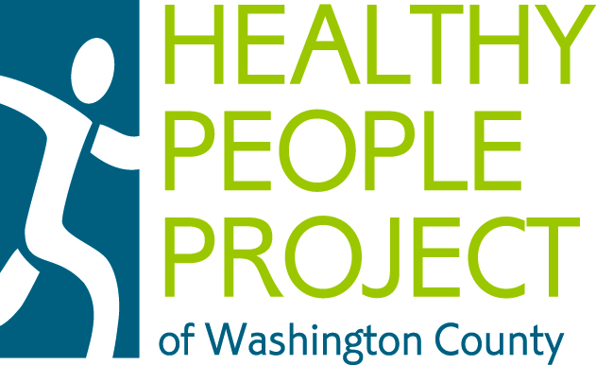
Join other bike commuters and bike enthusiasts Friday, May 16, 2014 from 6:00am-8:00am at the Train Depot in West Bend (200 Wisconsin St.). This is along the Eisenbahn Trail, across from the Museum of Wisconsin Art. There will be complementary refreshments and coffee, great raffle prizes including bike gear and a membership to the Kettle Moraine YMCA.
Free tech support will be available from Mountain Outfitters and Pedal Moraine will be providing a Fix-a-Flat clinic. New this year...A representative from the Wisconsin Bike Fed will be on hand to provide commuters with information on the basics of commuting by bike.
Find out from your employer if they are participating in the Summer Bike to Work Challenge. Bike to Work Day is the kick off to this challenge.
For any last minute updates please check our website or Facebook page.
Many thanks to our 2014 sponsors:
Dunn Bros. Coffee
First Weber, Brittany Nigh
Healthy People Project
Kettle Moraine YMCA
Kruepke Printing
Mountain Outfitters
Ozaukee Washington Land Trust
Pedal Moraine
Visual Graphics
Wisconsin Bike Fed

